Title: **RSLogix Addressing** Job: 4

Course: Introduction to Automation Unit: Introduction to PLC CLO: 4

Name ____________________________ Station _______ Date ______________

**Objectives**

1. Student shall complete configuration to establish communications with a MicroLogix PLC.
2. Student shall relate the IP configuration of a personal computer with that of a PLC using the RSLogix 500 software application.

**Assessment**

Students shall demonstrate a comprehension of the objectives listed above by scoring a minimum of 75% on this shop job. Grading shall be based on the Introduction to PLC rubric.

**Instructions**

1. Connect an Ethernet cable from your computer to the MicroLogix 1100 programmable logic controller.

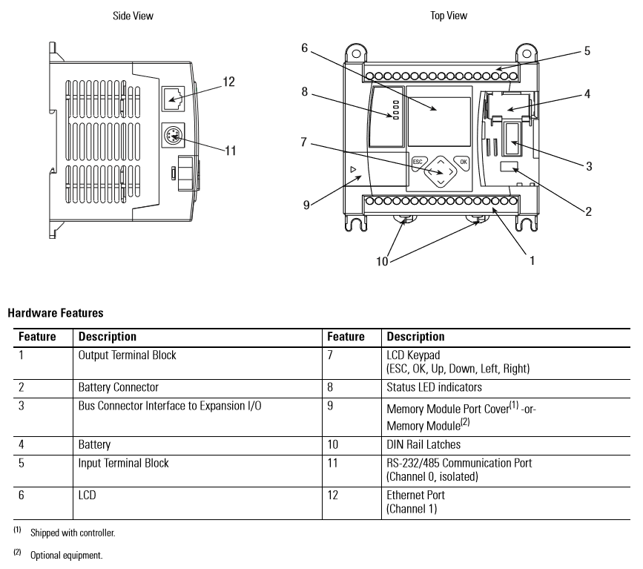

1. Power-up the MicroLogix 1100 by turning on the circuit breaker on the training panel. The square under COMM1 should be filled-in.

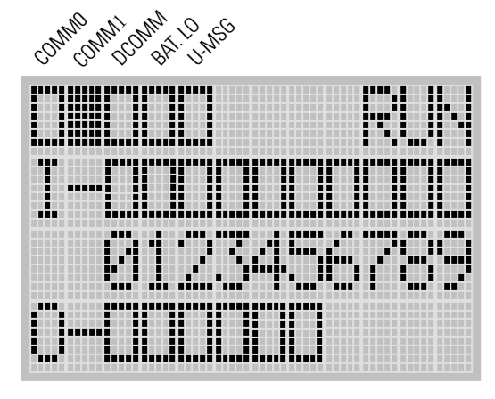

1. Ensure that the computer’s wireless system is turned off by pressing the  button at the upper right portion of the computer. The wireless symbol on the button should change to orange when the wireless function is off.
2. MAC Address Discovery - On the MicroLogix 1100, press the [ESC] button to exit the status screen and return to the menu options. Press the down arrow on the front of the MicroLogix 1100 until you are pointed to the Advance Set and press [OK]. Press the down arrow until the ENET Cfg is selected and press [OK].

|  |  |  |
| --- | --- | --- |
|  |  |  |

1. Record the MAC address. MAC stands for Media Access Control address and is used for network addressing including Ethernet and Wireless addressing. It is unique to each specific network card. Record your specific MAC address. The PLC does not have an IP address yet. That will be our next step.
2. From the Windows desktop type BOOTP in the ‘Search the web and Windows’ input in the lower left corner of your monitor.



1. Select the BOOTP-DHCP Server Desktop app. This will open a window like that shown below.

|  |  |
| --- | --- |
|  | Use your IP address |

After entering the *Subnet Mask, Gateway and Primary DNS*, press *[OK]*

1. The window below will then be displayed. Locate the PLC’s MAC address in the upper window. Select your MAC address and press *[Add to Relation List]*.

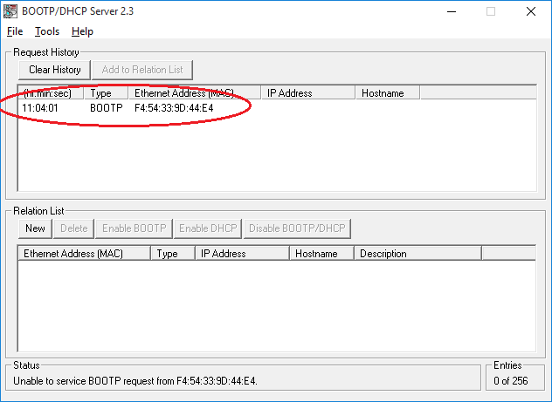

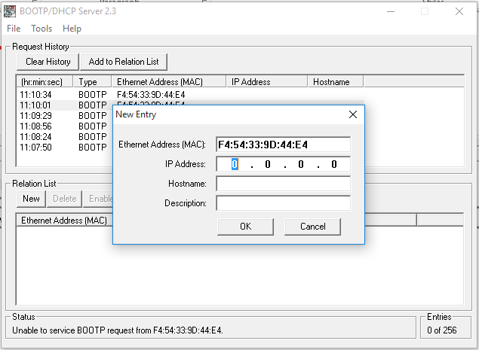

Here we will enter an IP (which stands for Internet Protocol) address for the PLC. An IPv4 address is made up of four octets separated by ‘dots’. Each octet can be a number between 0 and 255. See the instructor for the IP address of your computer.

1. Enter the first three octets of the computer into the IP Address field and make the fourth octet any value between 0-255 that is **not the same as** the computer’s fourth octet. If your computer’s IP address is 169.254.14.75, then the IP address of your PLC will be 169.254.14.*(any number between 0-255 that isn’t 75)*.
2. Enter a Hostname that begins with “ML” (for MicroLogix) and ends with two numbers and a letter that corresponds to the label on your MicroLogix PLC. So, if the PLC has a label 2A, the host name would be ML02A. The corresponding description would be MicroLogix 1100 PLC 02A.

Below is a completed screen. (Your addresses will be different)

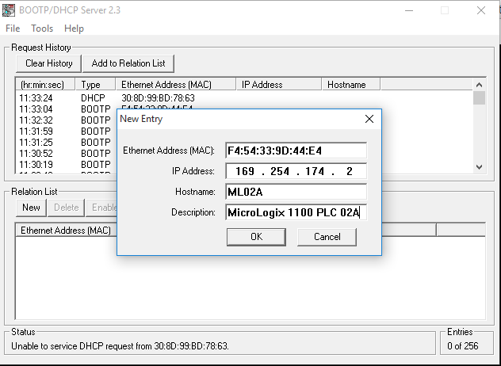

1. Ensure that the computer’s wireless is still off.
2. Highlight the PLC in the *Relation List* and press the [Enable BOOTP]. This will take a little while to complete.

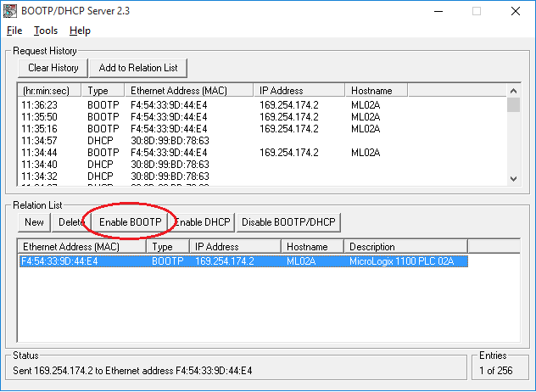

New address should show up here

1. Check PLC IP - Once complete, your PLC will display your related IP address.

|  |  |  |
| --- | --- | --- |
|  |  |  |

1. Save Boot Configuration - Save the boot configuration to be used at a later date. The filename should start with “ML” (for MicroLogix) and end with two numbers and a letter that corresponds to the label on your MicroLogix PLC.

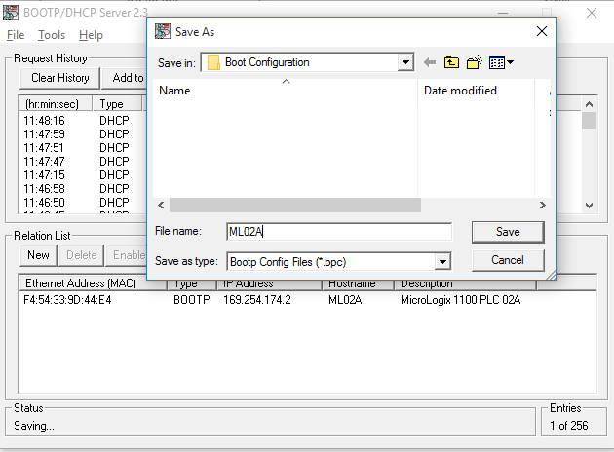

Once this procedure is complete and the configuration is saved, all that is required to establish communications with the PLC in the future is to invoke BOOTP and open the file that you just saved. The BOOTP server shall assign the IP address to the PLC based on the configuration that has been saved in this file.

This page left intentionally almost blank